Project Proposal

HR Management System

Salman Ahmed Khan, 19K-1043

Sadeem Sattar, 19K-1102

Abdulla Tilal Khan, 19K-1103

Team Leader: Sadeem Sattar

Advisor: Miss Bushra

26-Sep-21

**Contents**

1. Overview 3

2. Project Detail 3

2.1 Project Goals 3

2.2 Project Scope 3

2.3 Project Team 3

2.4 Existing Work 4

2.5 User Stories 4

2.6 Domain Model 4

3.Technologies 5

# Overview

This section describes a management summary. Provide essential information like

* + *The motivation of building HR management system is to provide automation to the HR activities which is carried out in every company and to provide flexibility in performing such activities.*
  + *The user of this project are Admin, HR, Employees and Account Department.*
  + *The project will deliver the effective performance to carry out HR duties. It is the new product.*
  + *It will take three months to build the project.*

# Project Detail

## Project Goals

The goal of the project is to provide ease to the HR Management Activities. Below are the listed goals:

* Provide registration for the new employee and the exiting employee by Admin.
* Manage employee attendance by HR.
* Leave Management by HR.
* Generate Employee Payroll by Account Department.
* Provide Announcement Message by the HR and Admin.
* Resignation Management of employee by the HR.
* Admin can manage departments, designations and Company Expense status.
* The Employee can view its details.

## Project Scope

The HR Management System will provide automation for the HR activities. The system will be in used with different level of users included Admin, HR staff, Employee and Account Department Staff. The system will provide ease and flexibility to the users.

## Project Team

Help: List all project team members here and ensure that the time they spend on the project is accounted for in the project.

|  |  |  |
| --- | --- | --- |
| **Name** | **Availability** | **Comment** |
| Salman Ahmed Khan | 2 hours daily |  |
| Sadeem Sattar | 2 hours daily |  |
| Abdullah Tilal Khan | 2 hours daily |  |
|  |  |  |
|  |  |  |
|  |  |  |
|  |  |  |

## Existing Work

The existing software of HR management system which was studied have following details:

* User Registration
* Payroll

The system which will be designed will have more than the above functionality and it will provide in maintaining employee records, payroll, leave management, attendance management, announcement messages by HR and Admin, departments, designations and expenses management and resignation management.

## User Stories

The admin can add the details of new employee in their system. They can also modify the existing employee details as well. The admin manages the department, designations and company expenses. The HR can manage the resignation of employee, attendance and leave management of employee. The admin and HR can do announcement messages. The Account department will generate the payroll of the employee. The employee can view all its details.

## Domain Model

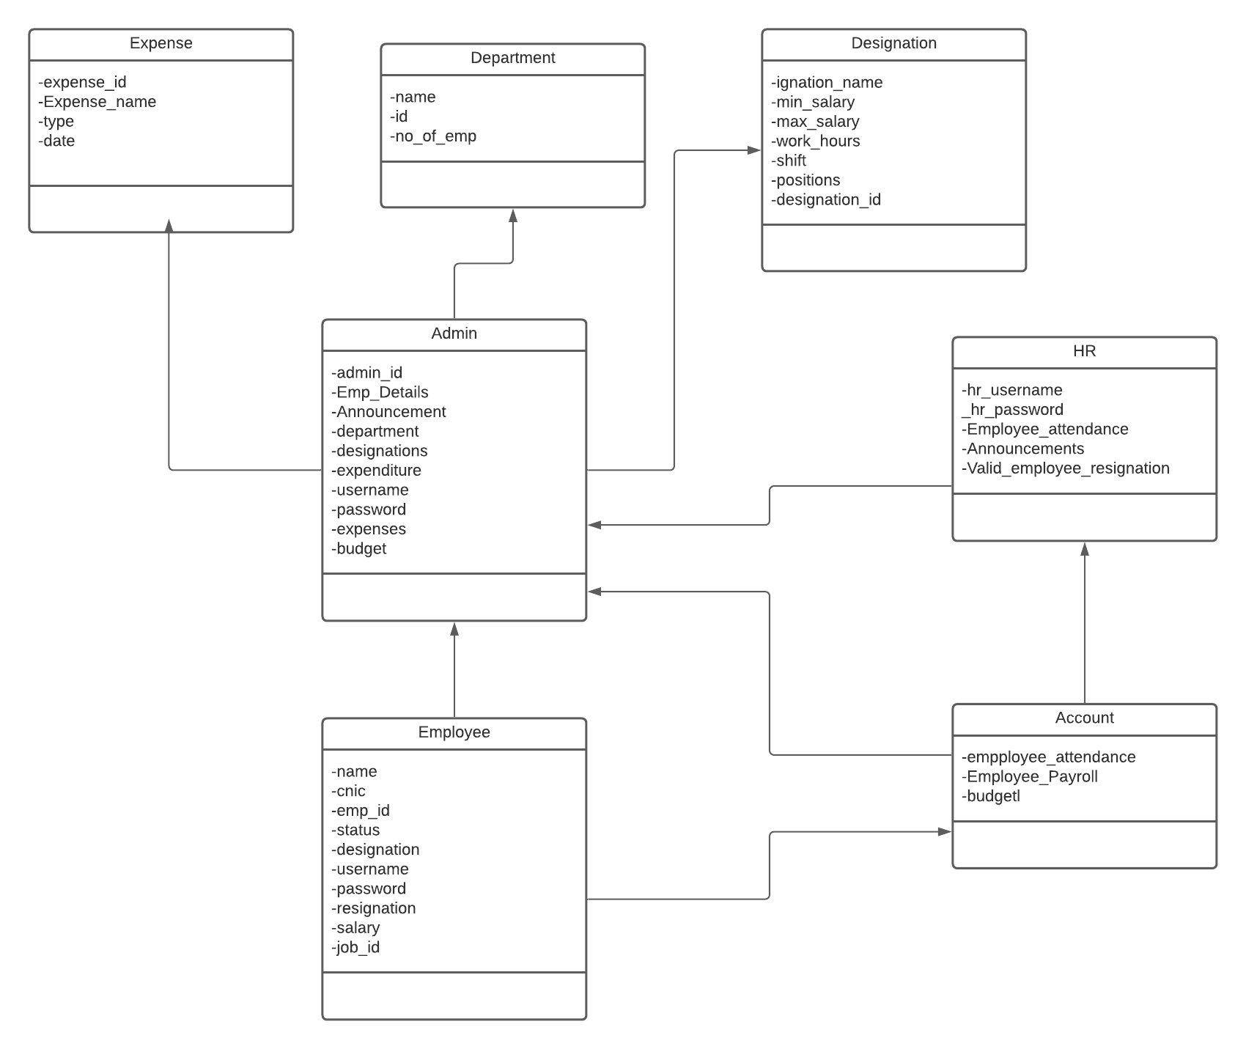

# 3.Technologies

*This project will be a web app. Therefore technologies that will be used in this project will be following:*

***FRONTEND:***

* *HTML/CSS/JAVASCRIPT*
* *REACT*
* *STYLING LIBRARIES (BOOTSTARP,MATERIAL UI)*

***BACKEND:***

* *NODE JS*
* *EXPRESS*

***DATABSE:***

* *MYSQL*